The Dublin City Community Enhancement Programme

Application Form 2019
Please read the Dublin City Community Enhancement Programme Guidelines 2019 before completing this form.
Please read the Terms and Conditions on Pages 2-3 of this application form.
All questions on this form must be answered.
Please sign the DECLARATION on Page 10 of this application form.

Please return completed, signed application forms to:
lcdc@dublincity.ie

OR

Dublin City Local Community Development Committee
Housing and Community Services
Dublin City Council
Civic Offices
Block 1, Floor 3, Wood Quay
Dublin 8

By 5pm, 14th June 2019
Late, incomplete or unsigned applications will not be accepted

The Department of Rural and Community Development (the Department) operates a community enhancement capital grant scheme through the Dublin City Local Community Development Committee (LCDC) and Dublin City Council. A total of €212,306 is available in 2019 for groups/organisations in Dublin City.

The LCDC, under the Community Enhancement Programme 2019, is now inviting applications from community or voluntary groups and not-for-profit organisations for capital funding. Applications for funding must clearly demonstrate how the funding will contribute to Goal 2 of the Dublin City Local Economic and Community Plan 2016 -2021:

Work in partnership with communities to promote social inclusion, tackle poverty and disadvantage, and promote participation, empowerment and positive social change.

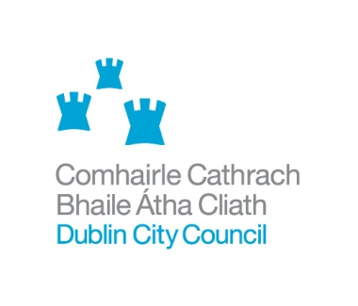
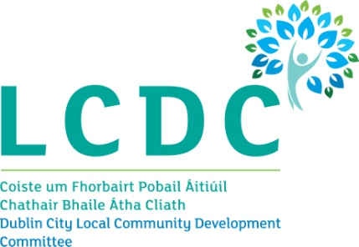
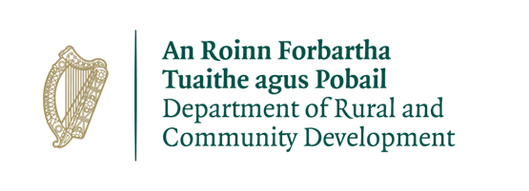

Dublin City Community Enhancement Programme 2019

Terms and Conditions
- The Department, under the Community Enhancement Programme 2019, will support capital projects subject to available resources.
- Applications for funding will be assessed against the criteria listed on Page 3 of the Dublin City Community Enhancement Programme Guidelines 2019
- Funding will only be awarded for capital projects taking place within the Dublin City Council area.
- The information supplied by the applicant group /organisation must be accurate and complete and signed. Misinformation may lead to disqualification and/or the repayment of any grant made.
- The Department of Rural and Community Development, the Dublin City LCDC and Dublin City Council reserve the right to publish a list of all grants awarded including the name of the group or organisation in receipt of funding and the general location of the group.
- The Freedom of Information Act 2014 applies to all records held by the Department and Dublin City Council. Under the Freedom of Information Act 2014, details contained in applications and supporting documents may, on request, be released to third parties. If there is information contained in your application which is sensitive or confidential in nature, please identify it and provide an explanation as to why it should not be disclosed. If a request to release sensitive information under the legislation is received, you will be consulted before a decision on whether or not to release the information is made. In the absence of the identification of particular information as sensitive, it could be disclosed without any consultation with you.
- It is the responsibility of each group/organisation to ensure that it has proper procedures and policies in place including appropriate insurance where relevant. A specific indemnity to Dublin City Council noted on your Public Liability Policy, in relation to the grant received from the Community Enhancement Programme 2019, is required.
- Where relevant, applicants must provide evidence of a Child Safeguarding Statement and meet all the requirements of the Children First Act 2015 which includes Garda vetting for all officers and those associated with the project.
- Applicants must ensure that all necessary statutory permissions or consents have been obtained before any works commence. This includes but is not confined to planning permission.
- All goods and services or works purchased with Community Enhancement Programme funding, must be procured on the basis of the Public Procurement Guidelines available at https://ogp.gov.ie/advertising-on-etenders-grant-recipients-2/
- Applications must be on the official Dublin City Community Enhancement Programme Application Form 2019.
- Evidence of expenditure, such as receipts/invoices marked paid must be retained and provided together with a short report on the use of the funding to the Dublin City LCDC or Dublin City Council.
- The Department, the Dublin City LCDC and Dublin City Council should be publicly acknowledged where feasible.
- Generally no third party or intermediary applications will be considered.
- Late applications will not be considered.
- Applications by post should use the correct value of postage stamps and allow sufficient time to ensure delivery not later than the closing date of Friday 14th June 2019 at 5pm. Claims that any application form has been lost or delayed in the post will not be considered, unless applicants have a Post Office Certificate of Posting in support of such claims.
- The funding offered must only be used for the purposes specified in the application and any alterations to the proposed grant must be approved in advance by the Dublin City LCDC.
- The full amount of the grant must be spent by 31st March 2020. Any unspent funding must be returned to the Department via Dublin City Council.
- The Department, Dublin City LCDC or Dublin City Council may carry out audits or unannounced site visits to verify compliance with the terms and conditions.
- Breaches of the terms and conditions of the grants scheme may result in sanctions including disbarment from future grant applications.

- PRIVACY (General Data Protection Regulation G.D.P.R.).
The purpose for processing your data is to process your application for the Dublin City Community Enhancement Programme 2019. The information you provide will be assessed by the Dublin City Local Community Development Committee, staff of Dublin City Council and external specialists, as required.

The Department of Rural and Community Development have the right to access all applications for funding.

Your information will be retained for five years. If you do not furnish the personal data requested, Dublin City Council will not be able to process your application.

You have the following rights, in certain circumstances and subject to applicable exemptions, in relation to your personal data:
- the right to access the personal data that we hold about you, together with other information about our processing of that personal data
- the right to require us to rectify any inaccuracies in your personal data
- the right to require us to erase your personal data
- the right to request that we no longer process your personal data for particular purposes
- the right to object to our use of your personal data or the way in which we process it

Please note that to help protect your privacy we take steps to verify your identity before granting access to personal data.

If you would like to exercise any of these rights, please submit a request to our Data Protection Officer outlining the specific details of the request: Email: dataprotection@dublincity.ie Tel: 01 2223775. All valid requests will be processed without undue delay and in any event within one month of receipt of the request. This period may be extended by up to two further months where necessary.

SECTION 1

APPLICANT GROUP OR ORGANISATION DETAILS
Name of Group / Organisation

Official Name of Group/Organisation per Bank Account details

Correspondence Address
(please include Eircode)

Year group or organisation established

Contact Name

Role in organisation

Telephone number

Email address (which will be used for correspondence)

Registered Charity Number (if applicable)

Tax Reference Number (if applicable)

Tax Clearance Access Number (if applicable)

SECTION 2

PURPOSE OF GRANT
Please answer each of the questions below to outline the purpose of the grant you are applying for under the Dublin City Community Enhancement Programme 2019. Remember that your application will be assessed against the information provided on this form only so your answers should be as specific as possible.

Please provide a description of the proposed project.

How will the work or project contribute to Goal 2 of the Dublin City Local Economic and Community Plan 2016 – 2021?

Work in partnership with communities to promote social inclusion, tackle poverty and disadvantage, and promote participation, empowerment and positive social change.

Please explain how your Group/Organisation works at a local level in areas of disadvantage or with individuals or communities impacted by disadvantage.

Please explain the need for the proposed project or purchase of equipment, the approximate number of people that will benefit and how often it will be in use.

How does your organisation link in with other groups or organisations in your local area or in your area of interest?

Where in Dublin City will the project or equipment be carried out or used? Where relevant, please confirm the owner of the site/building or the lease arrangements in place where the project will take place.

If successful, when will the equipment be purchased or the proposed project begin?

SECTION 3

TYPE AND STRUCTURE OF APPLICANT GROUP/ ORGANISATION
Please provide a brief description of the structure of your group or organisation, for example committee or board structure, meeting schedule, number of members or people involved in the group etc.

Does your Group/Organisation charge a fee for its services or membership? If yes, how much?

Has your group or organisation registered with the Dublin City Public Participation Network?

YES / NO (please delete as appropriate)

If you would like to know more about, or register with, the Dublin City Public Participation Network please go to www.dublincity.ie/ppn

SECTION 4

PROJECT BUDGET
Please provide the exact costing of the project or purchase of equipment below. You must supply evidence for the cost of the project/purchase of equipment or element of the project/equipment that is being applied for under the Dublin City Community Enhancement Programme 2019. Please ensure that the evidence of cost is inclusive of VAT. A written quote or a print-out from the website of a supplier will count as evidence. If the project is being part-funded from another source, including applicant’s own funds, please provide evidence of the availability of any balance to the funding. If you do not provide this documentation with this form, your application will not be considered.

How much funding are you applying for under the Community Enhancement Programme 2019? (Please attach evidence of exact cost of project or work)

Grant Scale | Tick | Exact amount applied for (€)
Capital grant of up to €1,000  (€40,000 has been ring-fenced for this category) |  | €
Capital grant of €1,000 - €5,000 |  | €

Is this amount the partial or total cost of the project or purchase of equipment?
Partial / Total (delete as appropriate)

If Partial, please give the total project cost or cost of equipment €

Where will your group or organisation source any shortfall in funding?

Other sources of funding for this project or equipment  Please attach evidence of other sources of funding with this application. | Amount
 | €
 | €
 | €
 | €

SECTION 5

OTHER FUNDING
Have you received any other funding or grants within the last three years?

YES / NO (please delete as appropriate)

If YES please give details:

Year funding or grant received | Funding organisation | Amount awarded
2016 |  | €
2017 |  | €
2018 |  | €

If you have received any funding through Dublin City Council, have you submitted your Bank Account Details previously?

YES / NO (please delete as appropriate)

If Yes, Please give the details of your group or organisation that appear on the Bank Account

Name of Group or Organisation on Bank Account
Address
Contact name

Email address

Checklist for Dublin City Community Enhancement Programme Application Form 2019
Sections 1 to 6, Pages 4 - 10 completed

Section 4, Page 8 - Evidence of cost of proposed project / purchase of equipment attached with application form
Section 4, Page 8 - If proposed project / purchase of equipment will be part-funded from another source evidence of shortfall attached with application form

Section 6, Page 10 - Declaration completed and signed by group / organisation Chair, Secretary or Treasurer

Where relevant, signed Child Safeguarding Statement attached

If the application is being posted, a Post Office Certificate of Posting obtained

SECTION 6

DECLARATION
I declare that the information supplied on this form is accurate and complete.

I confirm that I have read and fully understood the Terms and Conditions of the Dublin City Community Enhancement Programme 2019 (see pages 2-3 of this application form) and that this application is submitted in acceptance of and compliance with those Terms and Conditions.

I confirm that I have read the Dublin City Community Enhancement Programme 2019 Guidelines (available at www.dublincity.ie/lcdc) prior to completing this form.

I confirm that the applicant group or organisation does not have the funding to undertake the project or purchase the equipment without this grant aid or alternatively that with the grant the applicant group or organisation will now undertake a larger project or purchase equipment which they otherwise would not be able to afford.

I confirm that the applicant group or organisation is tax compliant (if tax registered).

I agree to Dublin City Council using the contact details given in relation to any future community grants or events. Yes No

Print Name (on behalf of group or organisation)

Position held in group or organisation
(Chairperson, Secretary or Treasurer)

Signature

Date

